How to import blender models into unity

1. Create Model in unity

1. Hit file then export as .fbx

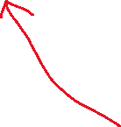

Make sure apply transform is on so there are no hiccups with unity

1. Drag and drop 3D object file into unity assets for use

1. Blender model is available for use, if no animation, disable animation import